### Title Page

**Title**: Analysis of the Different Mental Health Disorders  
**Author**: Oyedele Ayomide  
**Date**: 17/09/2024

### Executive Summary

* **Purpose**:  
  The purpose of this project is to analyze various mental health disorders to understand their prevalence, symptoms, and the treatment options available. The goal is to highlight how these disorders affect individuals and to identify any gaps in public awareness and treatment.
* **Key Findings**:
  1. Anxiety disorders and depression are the most prevalent mental health conditions globally, with a significant overlap in their symptoms.
  2. Bipolar disorder and schizophrenia are less common but are often associated with more severe symptoms, significantly impacting daily functioning.
  3. Treatment availability varies widely, with cognitive behavioral therapy (CBT) and medication being the most common forms of treatment across disorders.
* **Recommendations**:
  1. Increase awareness of less common mental health conditions, such as personality disorders and psychotic disorders.
  2. Expand access to mental health resources, particularly in regions with limited mental healthcare infrastructure.
  3. Encourage early diagnosis and intervention to prevent the worsening of symptoms in individuals with mental health conditions.

### Introduction

"State of well-being in which the individual realizes his or her abilities, can cope with the normal stresses of life, can work productively and fruitfully, and can contribute to his or her community" is how the World Health Organization (WHO) defines Mental Health.

Mental health disorders, however, have not always been given the attention they deserve. Historically, certain conditions like depression and anxiety have been more widely recognized, while others, such as schizophrenia or personality disorders, are often misunderstood or stigmatized.

In this project, various types of mental health disorders are analyzed, exploring how frequently they occur relative to one another, their symptoms, and the treatment options available. This helps in understanding how they impact individuals and in identifying opportunities for improved mental health care.

* **Objectives**:
  1. To understand the different types of mental health disorders.
  2. To analyze the symptoms associated with these disorders.
  3. To evaluate the available treatment options for these disorders.
* **Scope**:  
  This analysis provides insights into common mental health disorders and offers statistical evidence on their impact and treatment methods. However, the project does not dive into niche or rare disorders that have limited data.

### Data Description

* **Data Sources**:  
  The dataset analyzed for this project was sourced from Kaggle, a platform offering a variety of datasets for machine learning and data analysis.
* **Preprocessing Steps**:  
  The dataset required minimal preprocessing as it was mostly clean and well-structured. Columns were properly named, and only minor adjustments were made to ensure consistency in naming conventions and data formatting.

### Methodology

* **Analysis Techniques**:  
  The analysis was performed using Python programming language, with the use of libraries such as Pandas for data manipulation, NumPy for numerical operations, and Matplotlib for data visualization.
* **Reasoning**:  
  Python is a versatile language that allows for highly customizable and detailed data analysis. The use of these libraries facilitated an in-depth understanding of the dataset, enabling clear visualizations and data insights.
* **Validation**:  
  A t-test was applied to statistically validate the findings from the data analysis. This helped confirm any significant relationships between variables, such as the connection between certain disorders and the effectiveness of their treatment options.

**6. Results**

**Findings**:  
A total of seven datasets were analyzed to explore various mental health disorders and the relationships between them. A **heatmap** was used to display the correlations between the disorders.

Key discoveries from the **first heatmap** include:

1. Bipolar disorders and Eating disorders show a **positive correlation** of 0.68.
2. Eating disorders and Anxiety disorders have a **positive correlation** of 0.59.
3. Depressive disorders and Eating disorders exhibit a **negative correlation** of -0.052.
4. Schizophrenia and Eating disorders present a **positive correlation** of 0.5.

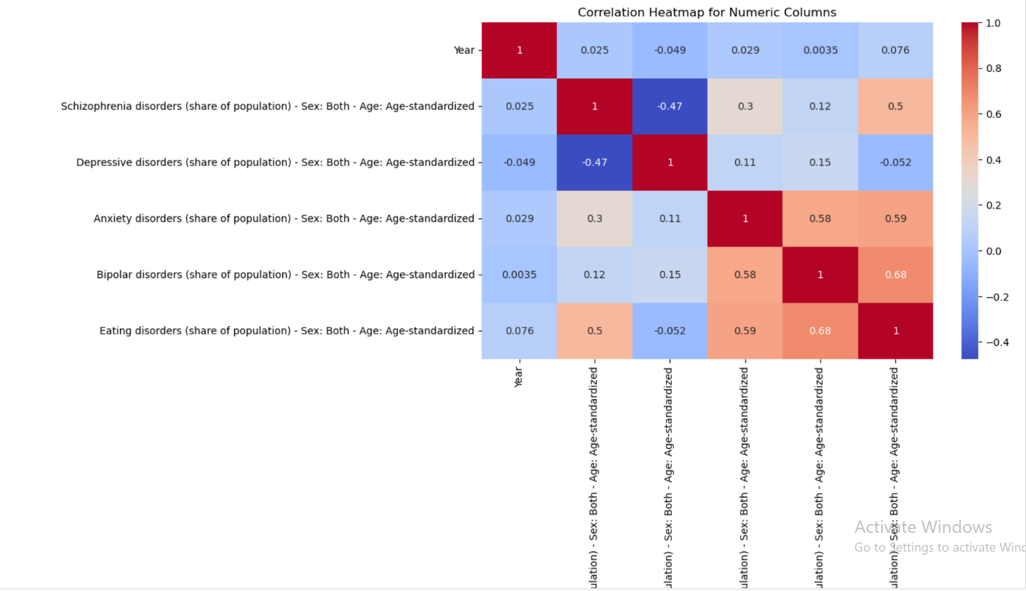

To better understand these correlations, a **bar chart** was plotted to visually compare the strength of the relationships.

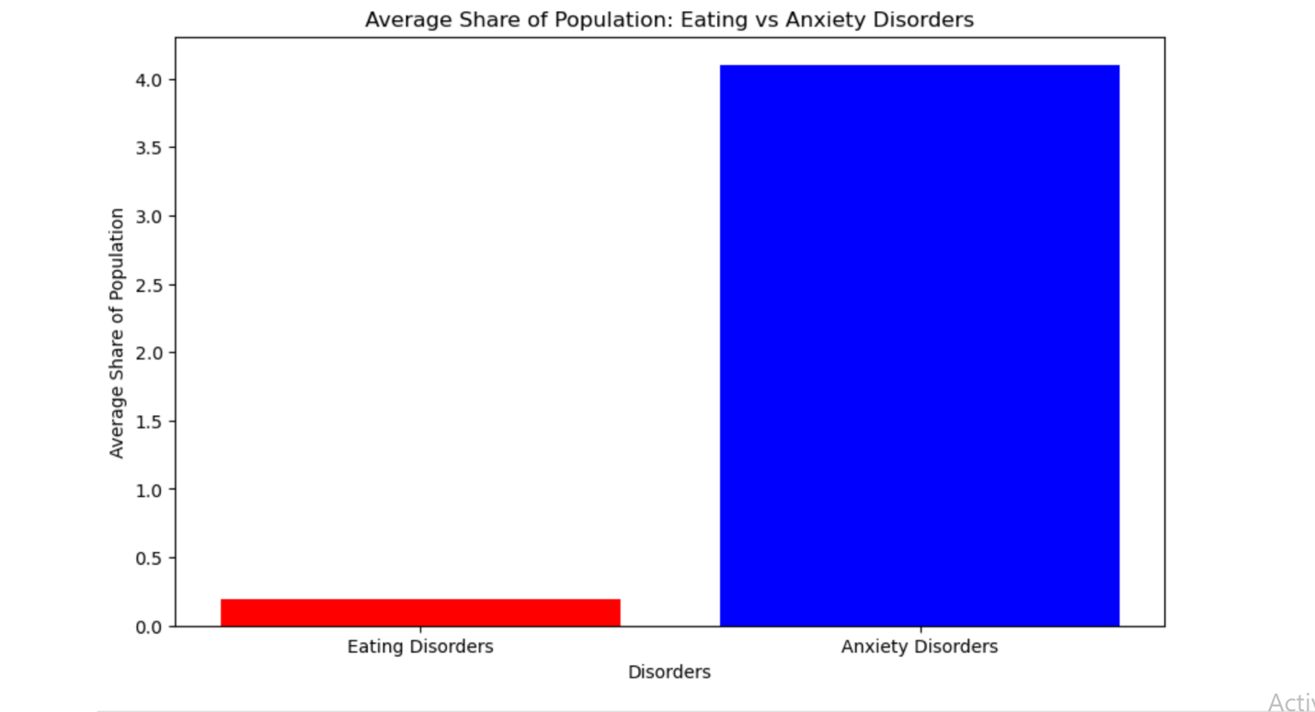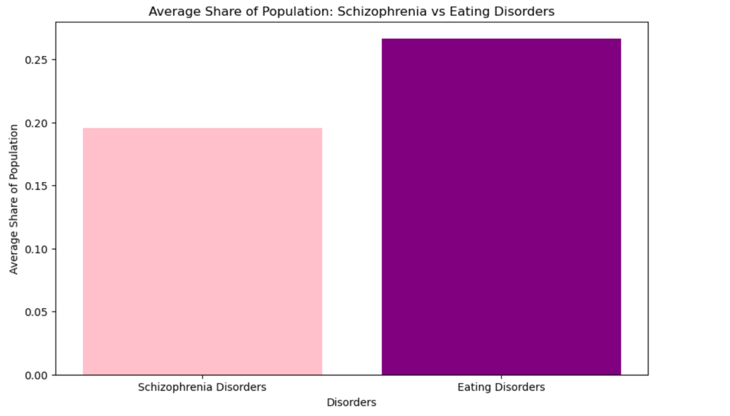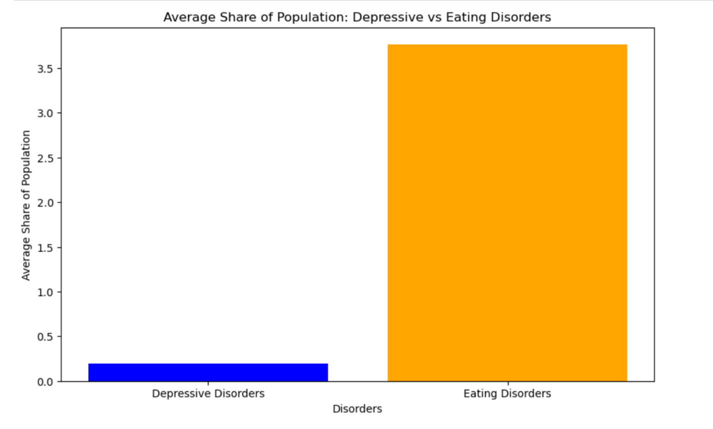

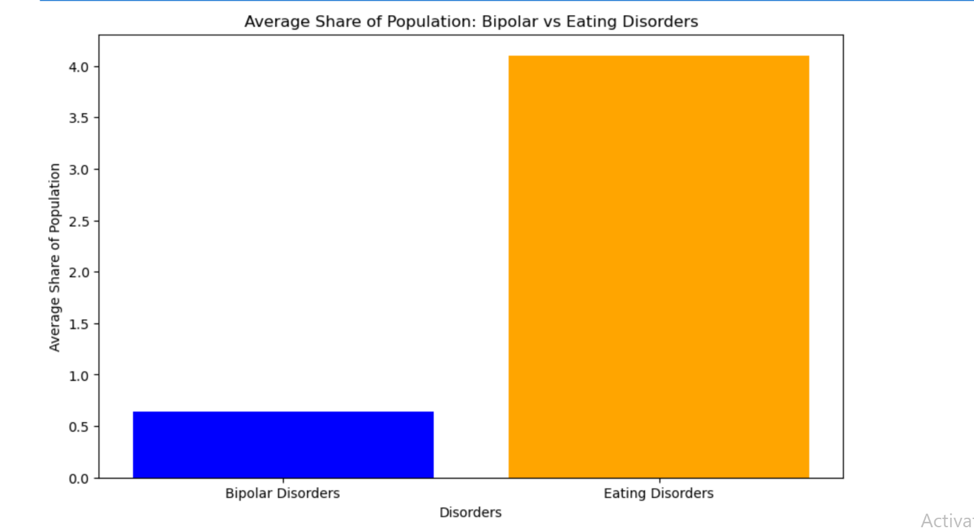

**DALY Dataset Findings**:  
Another dataset analyzed was based on the Disability-Adjusted Life Years (DALYs) for different mental health disorders. This dataset revealed the following key findings:

1. Anxiety and Eating disorders show a **positive correlation** of 0.6.
2. Anxiety and Bipolar disorders have a **positive correlation** of 0.58.
3. Eating disorders and Schizophrenia present a **positive correlation** of 0.48.
4. Bipolar and Eating disorders again show a strong **positive correlation** of 0.68.
5. Anxiety and Depressive disorders have a **negative correlation** of 0.16.
6. Anxiety and Schizophrenia present a **negative correlation** of 0.29.
7. **Year** shows a **negative correlation** with all mental health disorders, indicating that the rate of disorders has changed over time, but with a downward trend.

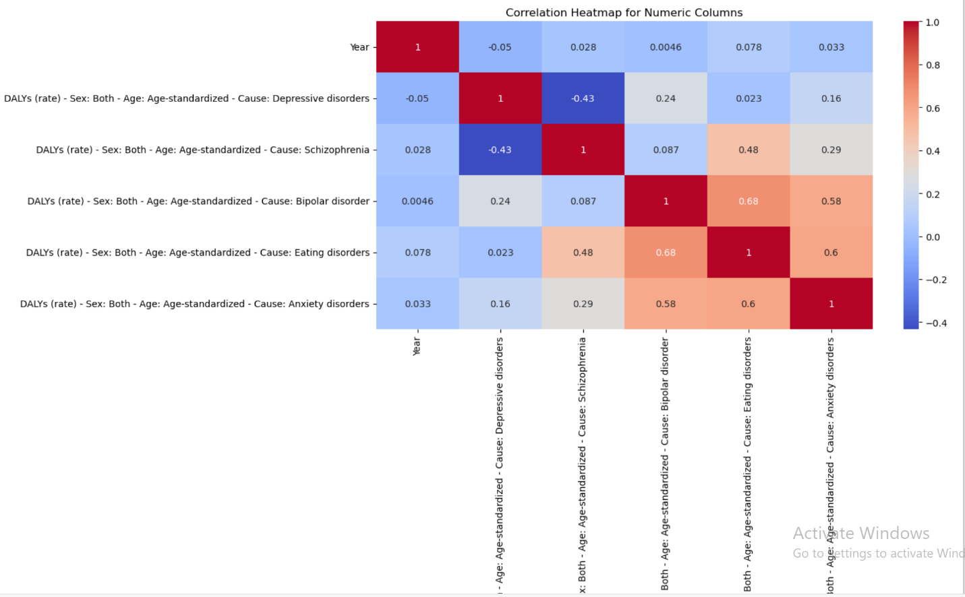

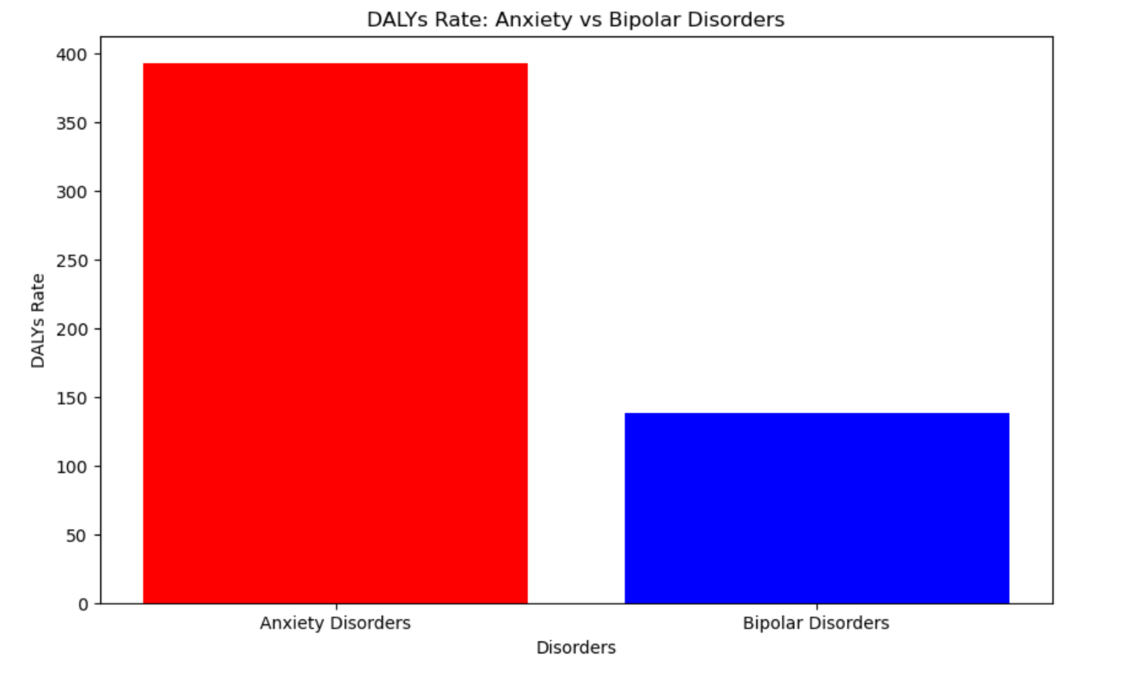

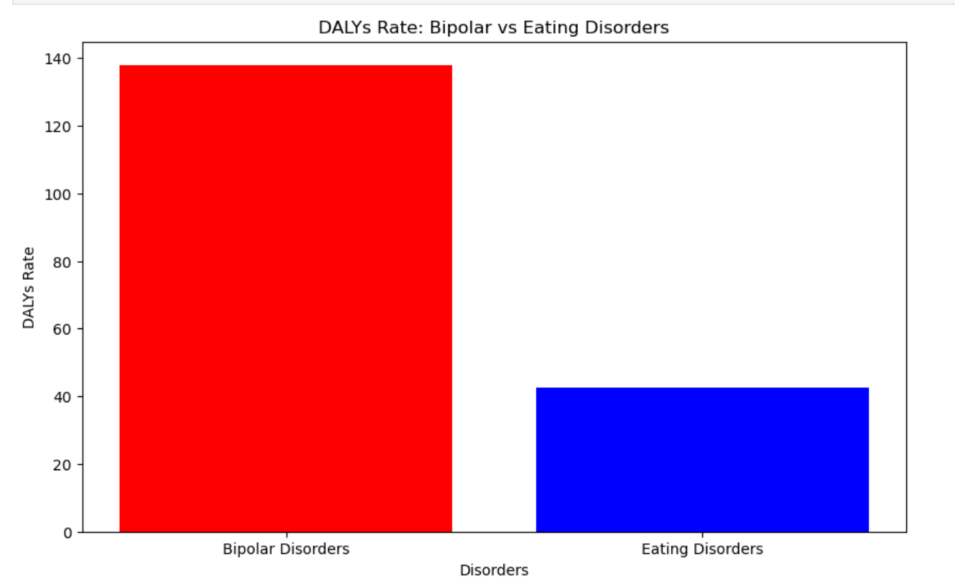

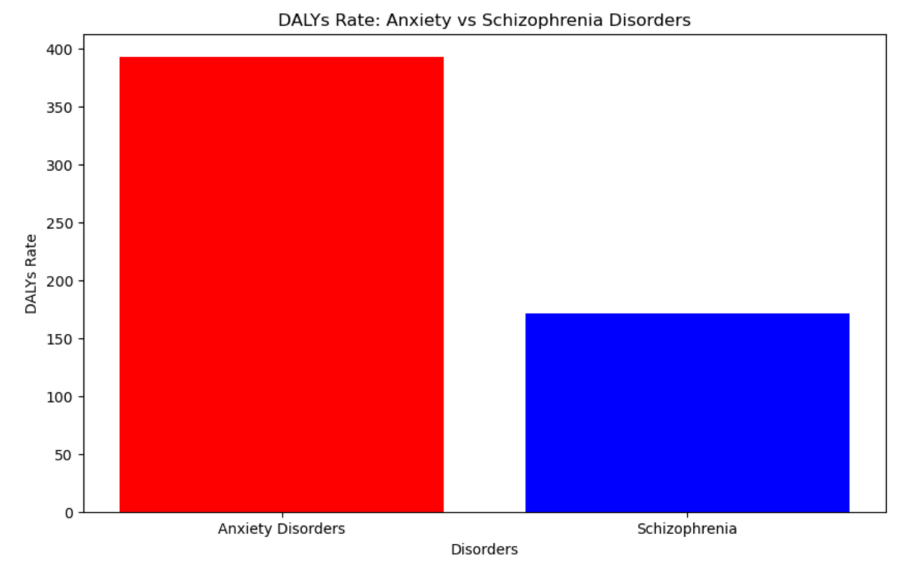

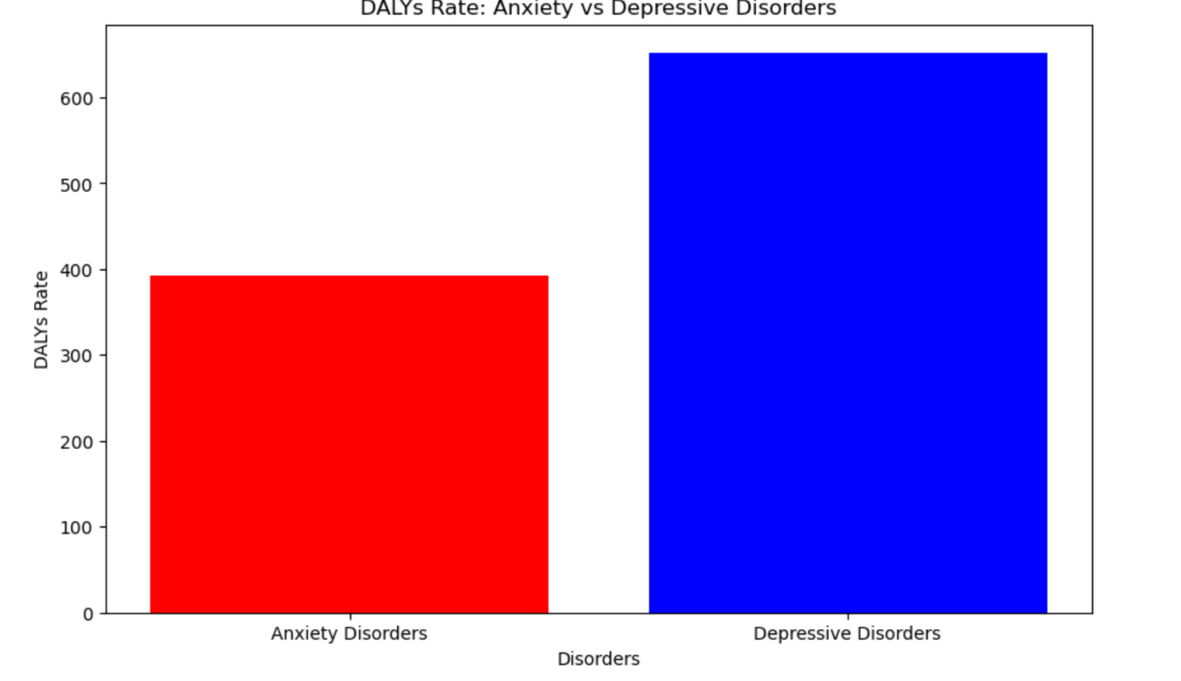

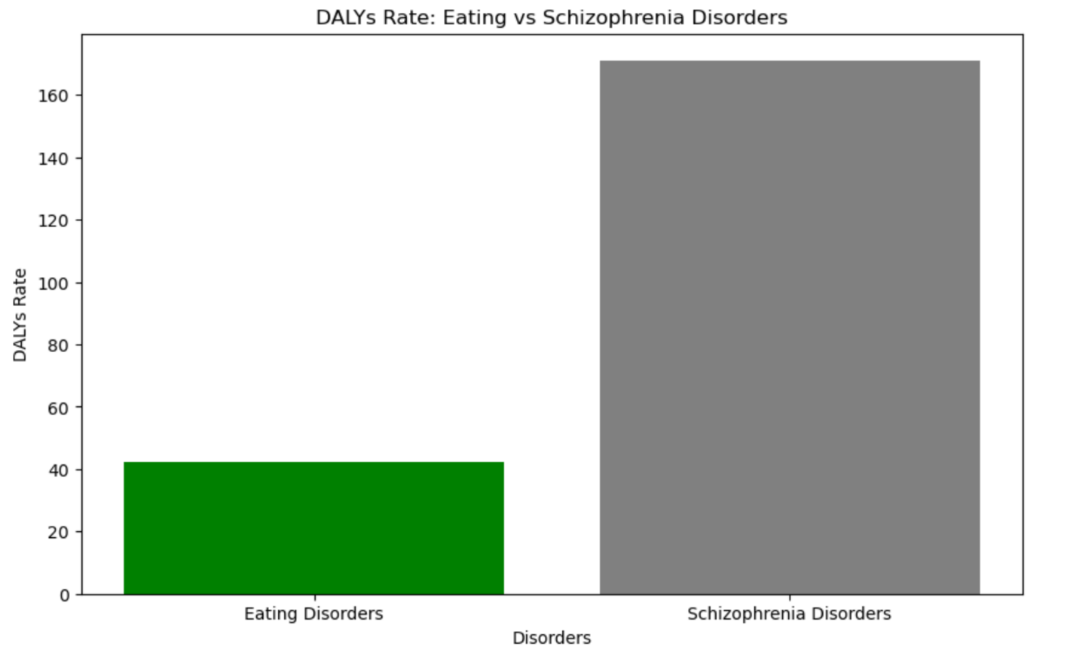

**Depression Rates Dataset**:  
A dataset was also analyzed to examine the **rate of major depression** over time. The analysis revealed that the **year 2008** witnessed a significant rise in major depression rates.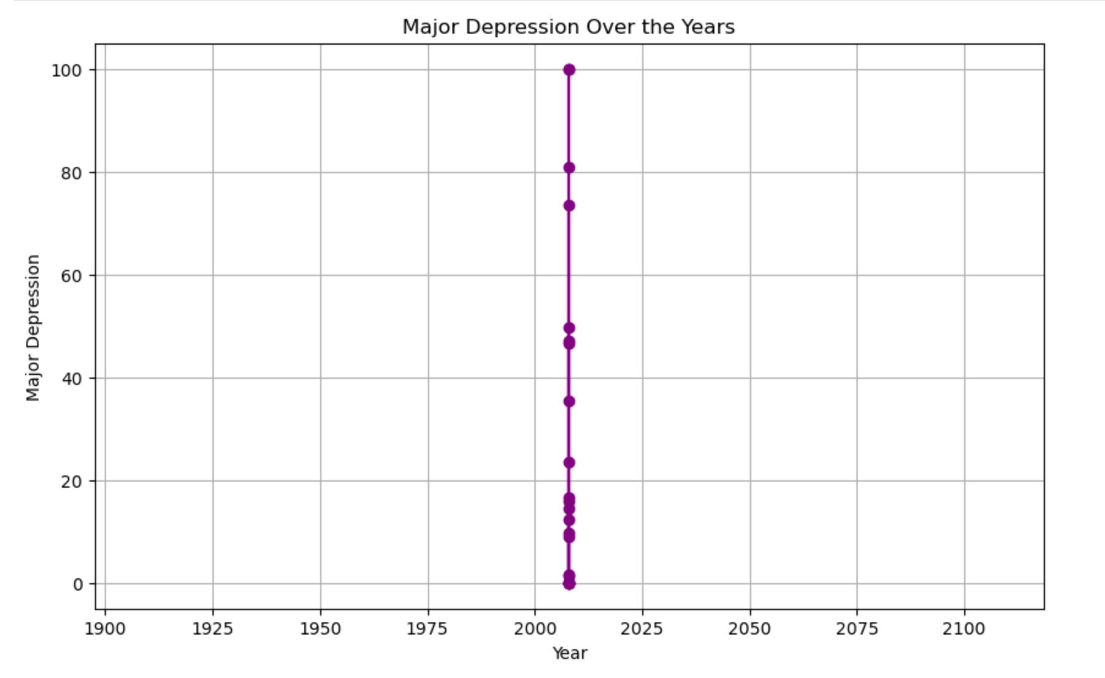

**Further Findings on Correlations**:  
Another dataset uncovered these insights:

1. Major depression and Anxiety disorders have a **positive correlation** of 0.88.
2. Anxiety and Bipolar disorders have a **negative correlation** of -0.68.
3. Anxiety and Eating disorders have a **negative correlation** of -0.63.
4. Dysthymia and Anxiety disorders have a **negative correlation** of -0.65.

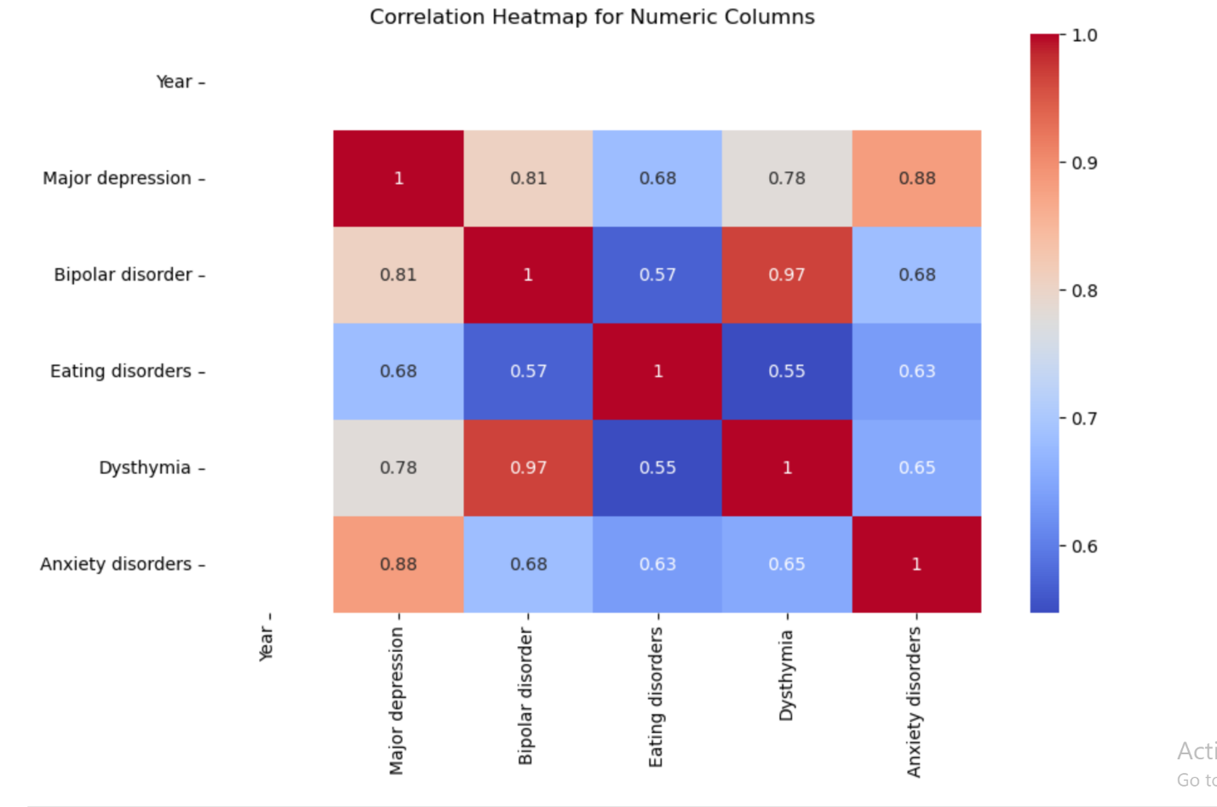

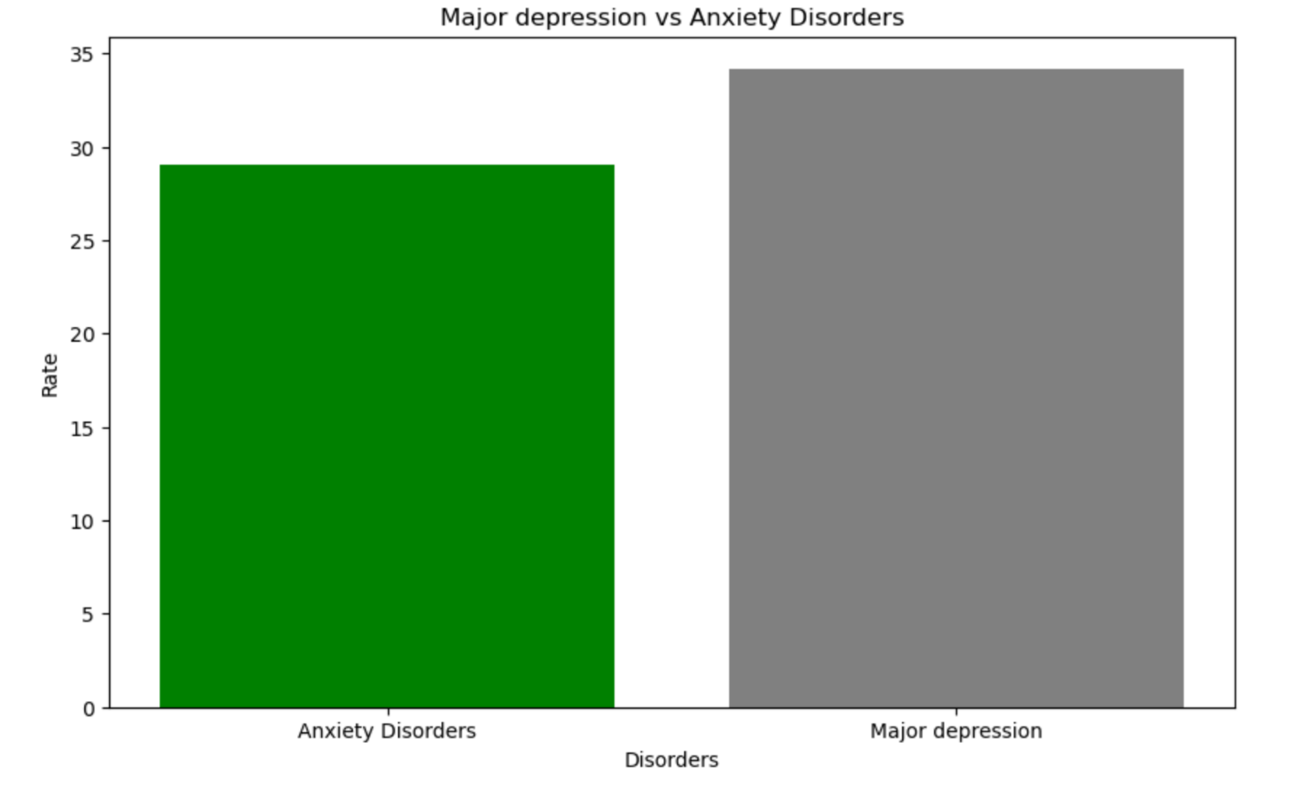

Only positive correlations were considered significant for further detailed analysis.

**Treatment Dataset Findings**:  
Analysis of a dataset on **treatment availability** provided the following observations:

1. **2003** had the highest rate of potentially adequate treatment available, whereas **2007** had the lowest rate.
2. Years **2010, 2011, 2013, 2014, 2016, and 2018** lacked reliable data on treatment adequacy.
3. **2012** showed a significant decline in available treatment, while **2007** had the lowest rate overall.
4. The untreated treatment dataset showed that untreated mental health conditions peaked in **2003**.

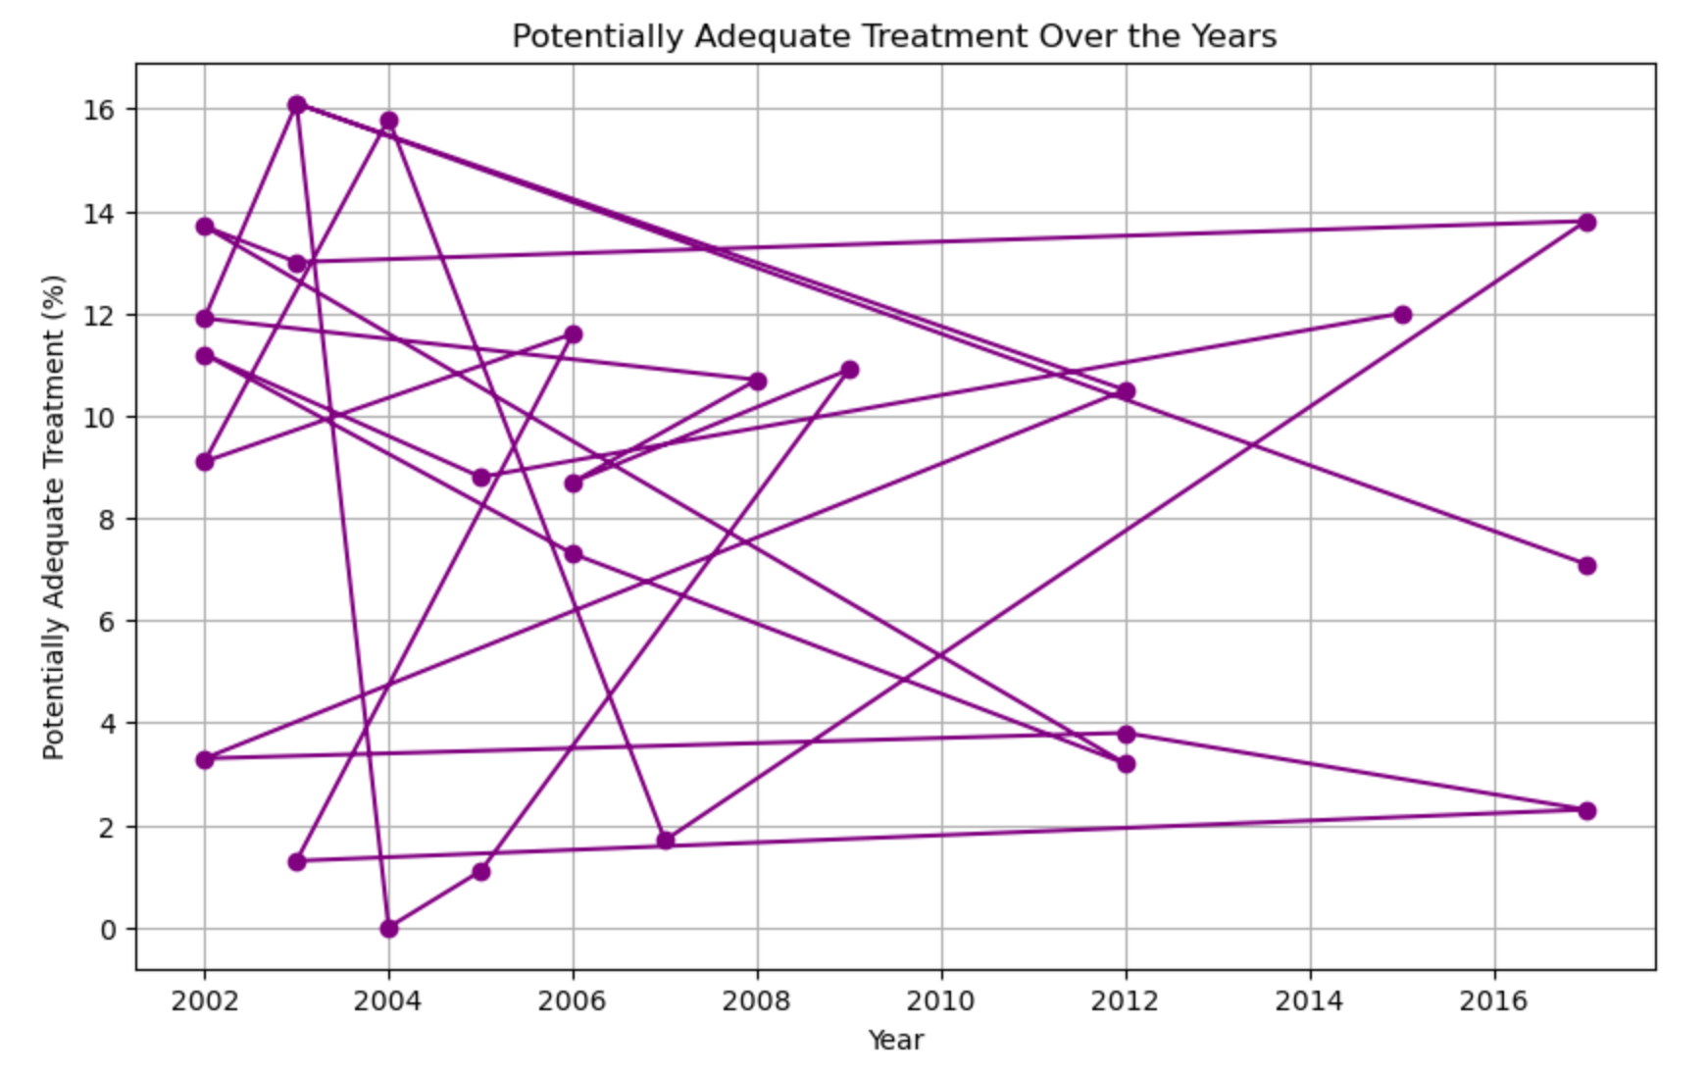

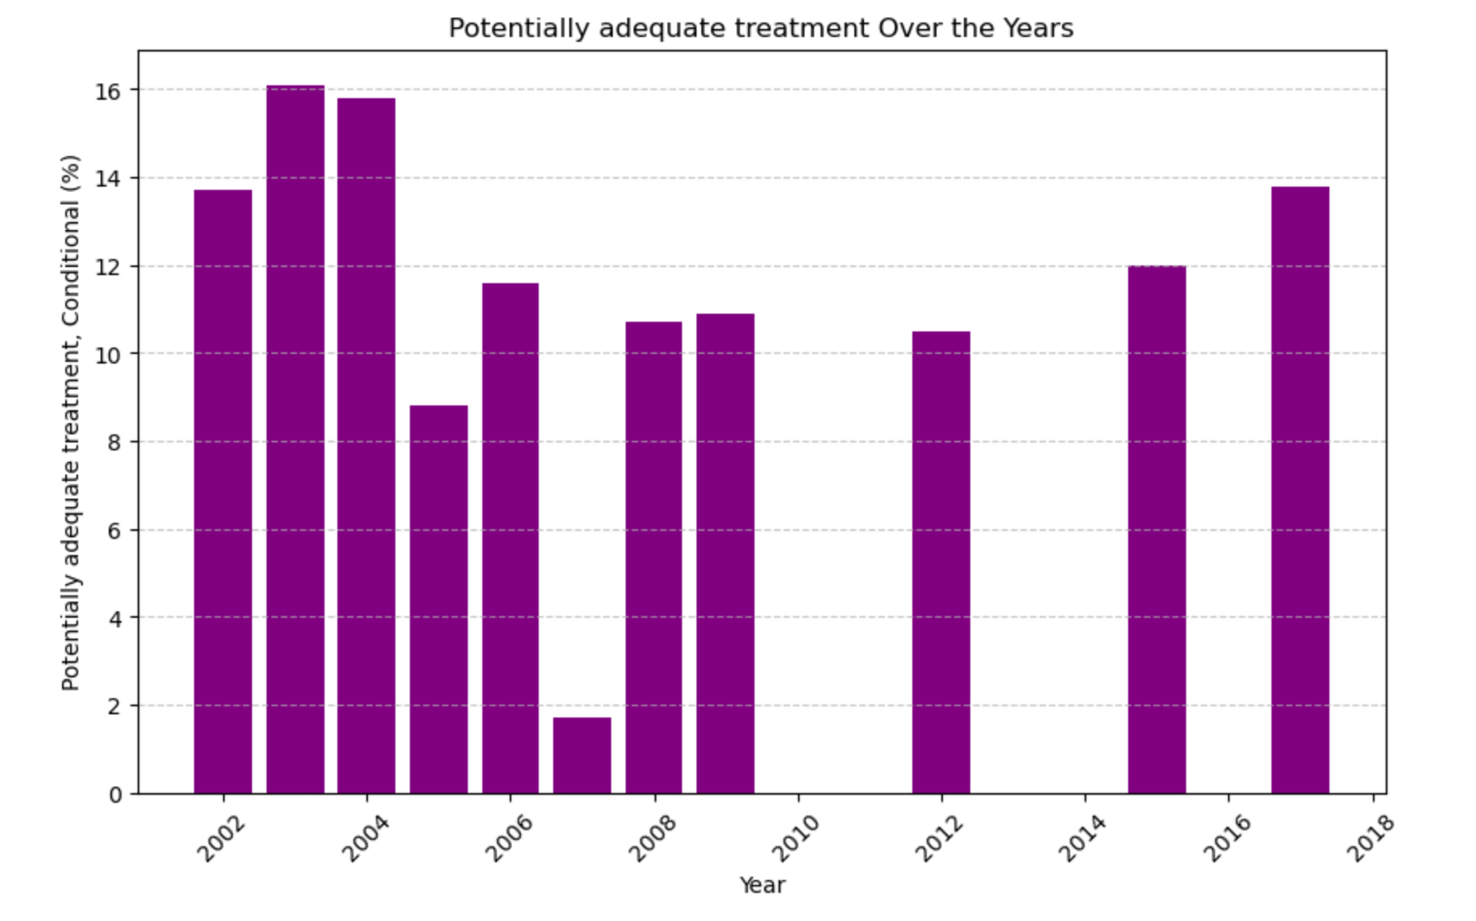

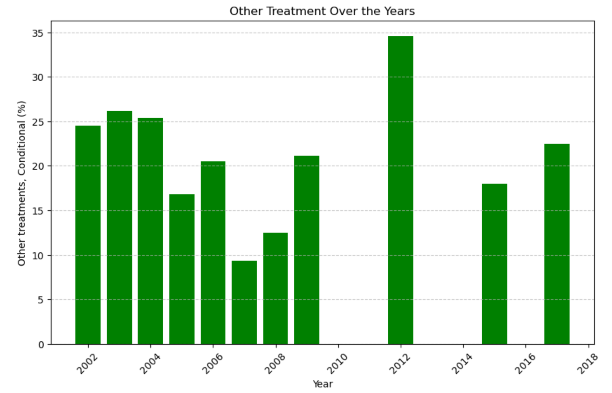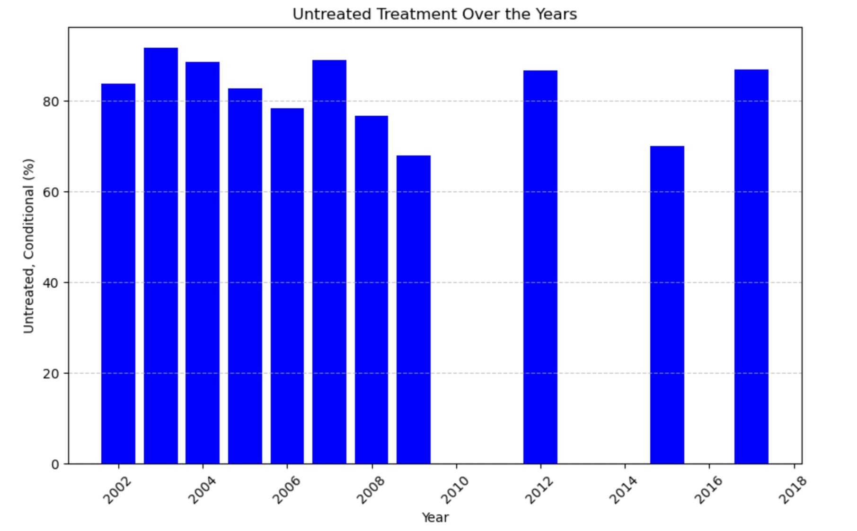

**Symptoms Dataset**:  
An in-depth analysis was performed on the symptoms experienced by individuals with mental health disorders. The key findings were:

1. The most commonly experienced symptom for **more than half of the day** was **low energy**, followed by **sleep problems**. **Suicidal ideation** was experienced less frequently.
2. For **nearly every day**, the predominant symptoms were **sleep problems** and **low energy**.
3. For **several days**, the symptoms mirrored those found in the "more than half of the day" and "nearly every day" categories.
4. **Not at all** experienced symptoms were **suicidal ideation** and **psychomotor agitation**.

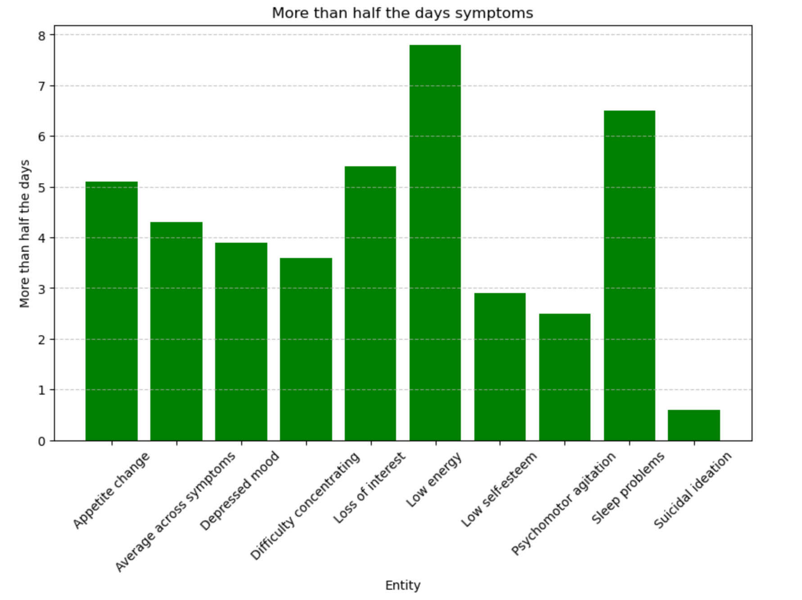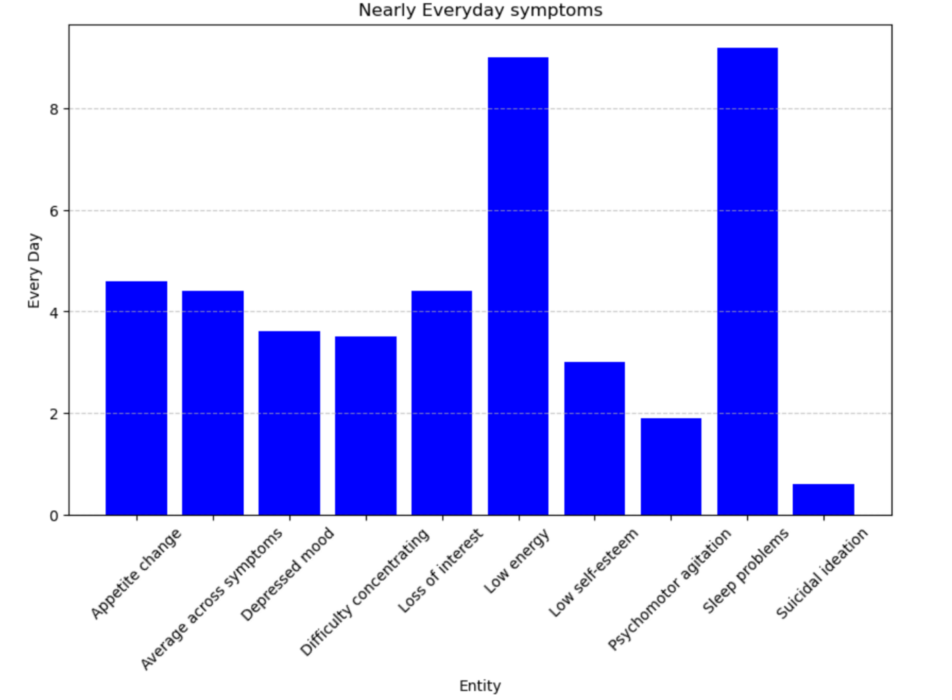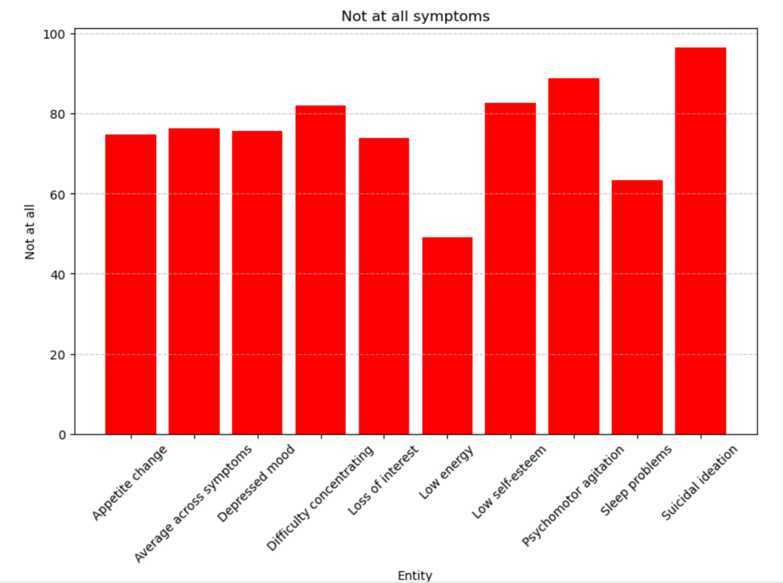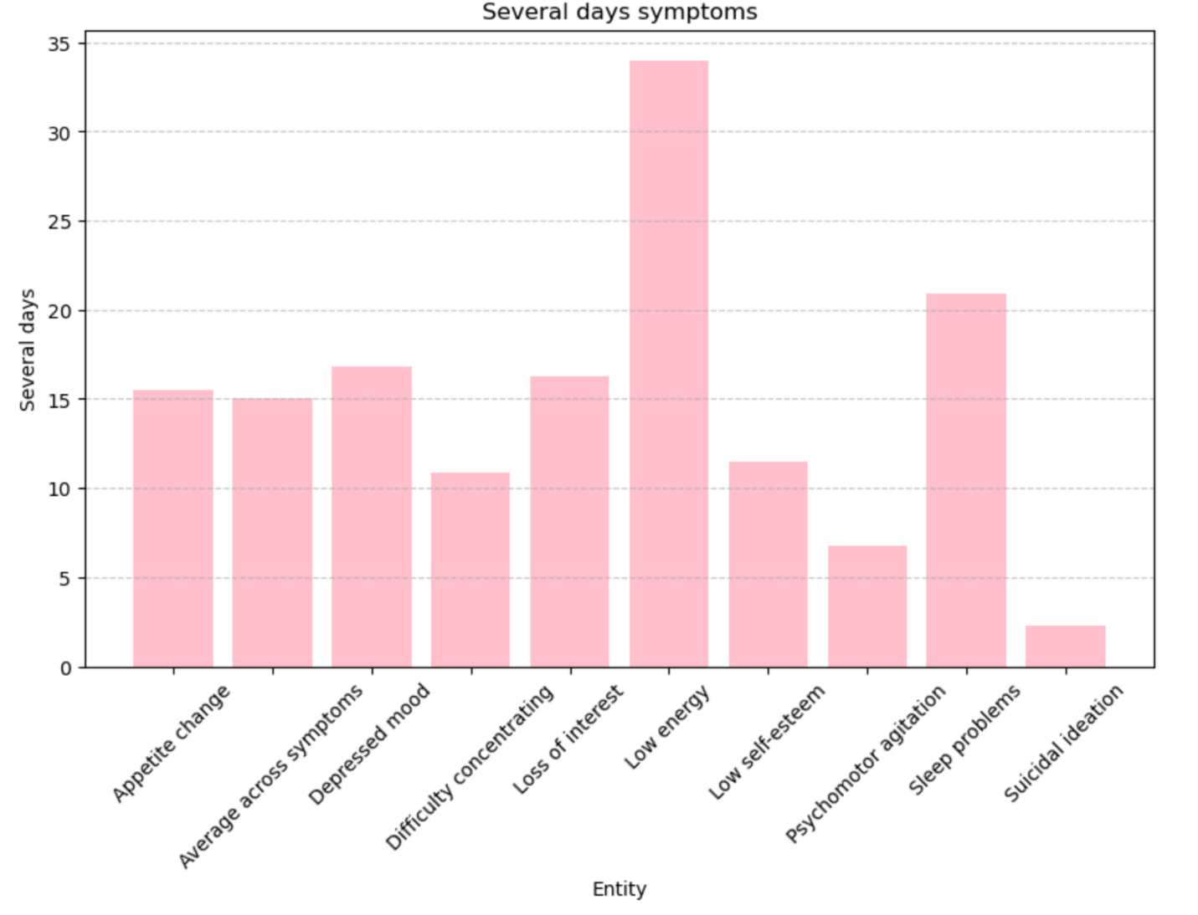

* A final dataset on disorder prevalence revealed that **Attention-Deficit Hyperactivity Disorder (ADHD)** was the most common across different countries, followed by **Cannabis Use Disorder** and **Major Depressive Disorder**. **Other drug use** and **Personality Disorders** were found to be the least common.

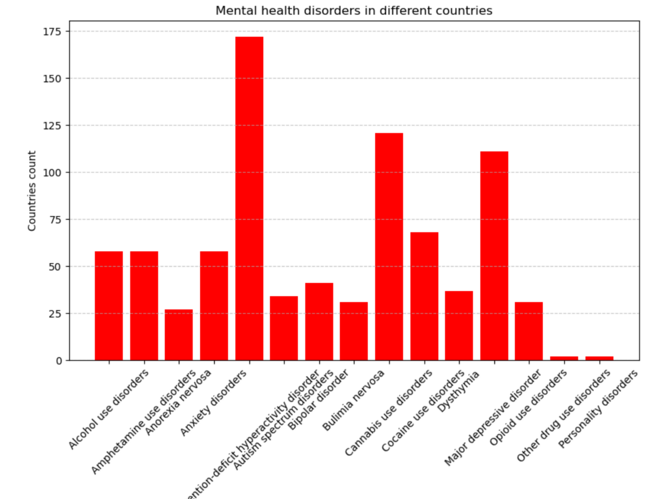

**Interpretation:** The analysis of the datasets reveals several important insights into the world of mental health:

* **Correlations between Disorders**:  
  The positive correlations between disorders, such as Bipolar and Eating disorders, indicate that there might be shared underlying factors or co-occurrence of these conditions in individuals. Similarly, Anxiety’s correlation with multiple disorders suggests that it is a common comorbidity in various mental health conditions.
* **Temporal Trends**:  
  The negative correlation with the **Year** suggests a gradual improvement or possibly changes in diagnosis or reporting standards over time. However, the increase in depression rates in 2008 highlights a significant event or societal change that may have impacted mental health during that period.
* **Symptom Analysis**:  
  The symptoms data provide a better understanding of the daily struggles faced by individuals with mental health disorders. The fact that **low energy** and **sleep problems** are recurring symptoms across various conditions shows the pervasive impact of mental health disorders on an individual’s physical and mental well-being.
* **Treatment Insights**:  
  The varying availability of adequate treatments over the years raises concerns about access to mental health care. Peaks in untreated mental health conditions point to gaps in healthcare provision that need to be addressed, particularly in certain years like 2007 and 2012.

These results emphasize the complexity of mental health disorders and the need for comprehensive and continuous care.

**7. Discussion**

* **Implications**:  
  The findings provide a deeper understanding of the relationships between various mental health disorders and their impact on individuals. The positive correlations between disorders such as **Bipolar and Eating disorders** and the significant association between **Anxiety and multiple disorders** suggest that comorbidity is a critical factor in mental health. This indicates that many individuals suffer from multiple disorders simultaneously, which can complicate treatment and require more holistic approaches. Additionally, the **symptom analysis** highlights how mental health issues affect daily life, especially through physical manifestations like **low energy** and **sleep problems**, showing that mental health has wide-ranging impacts beyond emotional well-being.
* **Limitations**:  
  Several constraints affected the analysis:
  1. **Data Gaps**: Certain years (e.g., 2010–2014) lacked complete data on treatment availability, which may have affected the conclusions regarding trends in treatment adequacy.
  2. **Dataset Specificity**: The dataset used focused on common disorders and did not cover rarer or emerging conditions, limiting the generalizability of the findings.
  3. **Temporal Variations**: The analysis did not account for socio-economic changes, policy interventions, or major global events (e.g., the 2008 financial crisis) that might have influenced the trends observed in the prevalence of disorders.
* **Comparison**:  
  The findings align with existing research in several ways. The **prevalence of anxiety and depressive disorders** has been well-documented in mental health literature, and their significant correlation is widely acknowledged. However, the strong positive correlation between **Bipolar and Eating disorders** is less discussed in mainstream literature, suggesting that more attention could be focused on exploring these comorbidities. The temporal trends and treatment availability findings echo global concerns about mental healthcare access, which has been a focus of many recent studies on healthcare systems.

**8. Recommendations**

* **Actions**:
  1. **Public Awareness**: Increase awareness of comorbid disorders such as Bipolar and Eating disorders to facilitate early diagnosis and treatment.
  2. **Expand Mental Health Resources**: Governments and health organizations should prioritize expanding **treatment availability**, especially in underserved areas where there are significant gaps in access, as shown in years like 2007.
  3. **Holistic Treatment Programs**: Since many mental health disorders have overlapping symptoms (e.g., anxiety and low energy), mental health care should emphasize **integrated treatment approaches** that address multiple disorders and symptoms simultaneously.
* **Future Research**:
  1. **Longitudinal Studies**: Investigate the long-term effects of mental health disorders and the impact of comorbidity on treatment outcomes.
  2. **Socioeconomic and Cultural Factors**: Further research should examine how socio-economic conditions, cultural backgrounds, and global crises (e.g., COVID-19) affect the prevalence and treatment of mental health disorders.
  3. **Emerging Disorders**: Conduct research on less common or emerging mental health conditions to build a more comprehensive understanding of the mental health landscape.

**9. Conclusion**

* **Summary**:  
  This project analyzed seven datasets on mental health disorders, uncovering significant correlations between various conditions, symptoms, and treatment availability. Anxiety and depressive disorders were the most prevalent and correlated with several other disorders, emphasizing the need for integrated treatment. The analysis also revealed important temporal trends, particularly a rise in major depression in 2008 and fluctuations in treatment adequacy over the years. Symptom data showed the widespread impact of issues like low energy and sleep problems, which are shared across many mental health conditions.
* **Final Thoughts**:  
  The findings highlight the complexity of mental health disorders and the critical need for comprehensive, accessible care. Addressing gaps in treatment availability and increasing public awareness of lesser-known comorbidities are essential steps toward improving mental health outcomes globally. This project underscores the importance of early intervention and holistic care approaches to mitigate the effects of mental health conditions on individuals and society as a whole.